OT-One: Installing Pipettes

Learn how to properly install pipettes onto your robot

# This article is about the OT-One.

## **It's no-longer sold or actively supported by Opentrons, but we've kept this article here to help existing users. Please** [**see our OT-2 Support articles**](https://support.opentrons.com/) **for the most up to date information!**

## **Overview:**

The OT-One liquid handler uses manual pipettes to transfer liquids. Our robot can push the plunger up and down, similar to how your thumb would. In addition to moving the plunger, the robot’s 'thumbs' also press the pipette’s drop-tip button.

The OT-One comes with one single-channel pipette, and the PRO and Hood models come with both a single-channel and an 8-channel pipette. Your pipette(s) will be shipped pre-mounted within your accessory box for easy installation.

Your single-channel pipette can be installed on either the A (center) or B (left) axis, but the 8-channel will only fit on the A axis (see picture below):

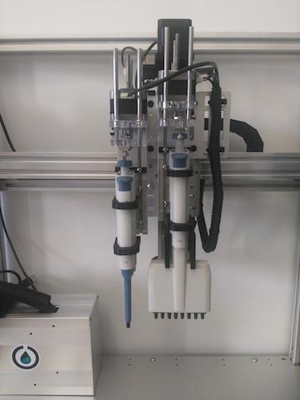

It is very important that when attaching a pipette, it is tightly fastened so that there are no movements during a protocol run.

## **Materials:**

In order to switch install your pipettes, the tools you will require are:

* Single or multi channel pipette (left)
* M4 Allen key (right)

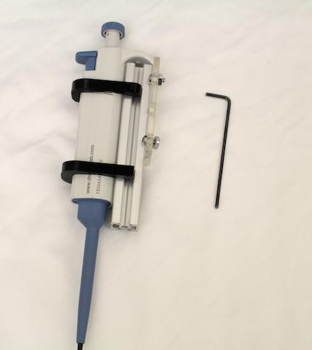

## **Procedure:**

Below are steps on how to make sure your pipettes are properly attached to the robot:

1. Make sure the ergonomic tail of the pipette is resting on the back acrylic mounting plate

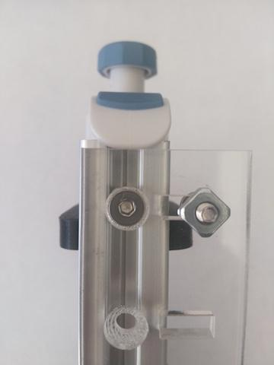

2. Loosen the two square fastening nuts on the acrylic mounting plate, so they can slide into the extrusion slot

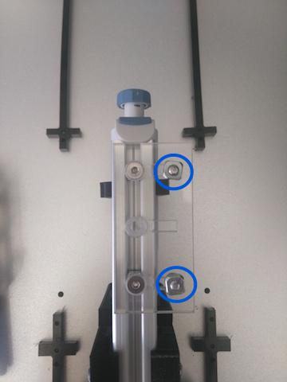

3. Align the square fastening nuts along the extrusion slot

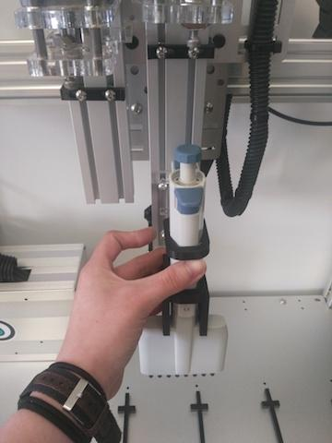

3. Slide your pipette upwards into the black stop bar, until the pipette’s ergonomic handle is pressed firmly against the black stopper.



4. Tighten the fastening screws so that your pipette does not move during a protocol run

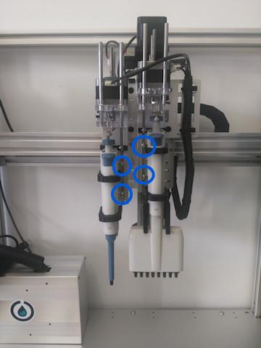

*\*\*If you have an 8 channel, install it first for ease of attachment.*

Make sure your pipettes are aligned vertically to ensure proper tip pick up.